Unit 4 Grade 10 Applied
Linear Systems

Lesson Outline

BIG PICTURE

Students will:
- solve systems of two linear equations, and solve related problems that arise from realistic situations.

A summative task and paper and pencil assessment are included as a part of the unit. Teachers can decide to use one or both assessments for the unit. If both assessments are used then the unit will last ten days.
The unit was written so that the use of CAS is integrated into every lesson. Although there are no examples showing specific screen shots, it is expected that students will have it available to use for solving and checking whenever needed. However, the materials in this unit can be used without CAS. A CAS user manual is included as well as video tutorials for the skills outlined in the manual. The manual and videos include keystrokes for the commonly used skill sets needed for linear systems such as solving for one variable or adding/subtracting two equations. This manual should be available to students as they work through the concepts in the unit. To be able to see the keystrokes, the TI Nspire key fonts must be installed on your computer. A guide to install the key fonts is included.
Day | Lesson Title | Math Learning Goals | Expectations
1 | Where Do We Meet? | - Identify/Solve problems that arise from realistic situations that can be modelled by two linear relations.  - Determine graphically the point of intersection of two linear equations.  - Interpret the story the graph tells, including point of intersection and what occurs before and after the intersection point. | ML1.02, ML 2.05 ML3.01, ML3.03  CGE 3c
2 | What’s the Point? | - Determine the coordinates of the points of intersection for pairs of linear relations given their graphs and interpret the meaning of the point of intersection.  - Solve a problem that arises from a realistic situation represented by two linear relations. | ML2.05, ML3.01, ML3.03
3 | Approximate or Accurate? | - Discuss accuracy of solutions obtained through graphical means.  - Establish the need to isolate a variable in order to use the substitution method and practice the skill of isolating.  - Develop understanding of facility of solving systems using the substitution method to improve the accuracy of a solution. | ML1.01, ML1.03, ML3.02  CGE 2c, 5b
4 | The SubMathiner | - Determine the conditions for which a linear relation application is preferred to the algebraic models by comparing the rate of change and initial value of two linear relations making up a system of equations.  - Identify which variable is the most efficient for isolating and then solve linear systems using the method substitution. | ML3.02, ML3.03

Day | Lesson Title | Math Learning Goals | Expectations
5 | There Is Another Way! | - Identify situations where the solving by substitution is not efficient.  - Identify necessary conditions or “look-fors” that make solving by elimination possible.  - Develop the algebraic method of solving a system by elimination. | ML3.02, ML3.03  CGE 4b, 7b
6 | There Is Another Way! - Part II | - Determine that an equation multiplied by a constant is equivalent to the original equation.  - Develop a complete algorithm for the algebraic method of elimination to solve a linear system.  - Solve problems using the method of elimination that arise from realistic situations described in words. | ML3.02, ML3.03
7 | Which One is Best? | - Identify necessary conditions or “look-fors” in a system of equations that make it best suited to be solved by graphing, substitution or elimination.  - Solve a system of equations using two of the three methods.  - Solve a system of linear equations using the most appropriate method. | ML1.01, ML1.03, ML3.01, ML3.02, ML3.03  CGE 3c, 4f, 5a, 5e
8 | Summative Task Evaluation – Day 1  This is available from the members only section of the OAME web site www.oame.on.ca | - Create contextual linear systems problems, complete with solutions and graphs, and present them in a visual format e.g., poster project or PowerPoint slideshow. | ML1.01, ML1.03, ML3.01, ML3.02, ML3.03  CGE 5b
9 | Summative Task Evaluation – Day 2 | - Exchange problems created amongst them for others to solve, verify their solutions, and justify the selection of preferred method of solution.  - Finalize their three linear-system problems, making necessary changes based on input from peers. | ML1.01, ML1.03, ML3.01, ML3.02, ML3.03  CGE 2c, 4f, 5e, 5g
10 | Final Evaluation  This is available from the members only section of the OAME web site www.oame.on.ca | - This is a one-day paper and pencil test that evaluates student learning for the remaining overall expectations and math processes.  - Students will apply their knowledge to generic situations, as well as real world contexts.  - Students will generate graphical and algebraic models from the data calculated in tables of value. | ML3.01, ML3.02, ML3.03
11 | Jazz Day

Nspire CAS Handheld Manual

Getting Started

When you turn on the handheld, press /N.

You will be asked whether you want to save the document. Select No. To do this, use the large circular “navpad” to move to the right, then press the xbutton in the middle of the navpad.

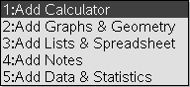
Next select 1:Add Calculator. To do this, press the x button again.

You are now ready to use CAS on the handheld.

Some Helpful Shortcuts
If you make a mistake at any point that you want to undo, press /Z.
If you undo something that you want back again, press /Y.

How to Solve for a Variable: Example One
Say that you wish to solve the equation 6x – 2y = 16 for the variable y.
To do this, first be certain that you are on a Calculator page. If you need help with this, see the Getting Started section above.
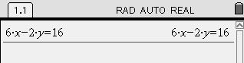
First type in the equation that you want to solve. Use the number pad and the green letter keys; the operations ( , , -, + ) are located on the right, and the equals sign ( = ) is in the top-left corner of the keypad. When you have typed in the equation, press the · key, found in the bottom-right corner.
The top of your screen will look something like this:

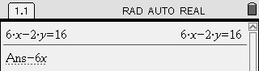
Now decide how you would start in solving for y.
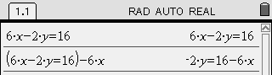
Perhaps you’ve decided that subtracting 6x from both sides of the equation is a good start. Wonderful! To do this, immediately press -6X. Notice that the handheld automatically inserts Ans . What is this?
Ans stands for the last answer you found. If you now press the · key, the handheld will subtract 6x from the left side and the right side of 6x - 2y = 16. You will see this result:
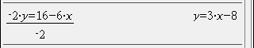
Continue solving the equation. You probably see that to finally isolate the y variable, it is necessary to divide the equation by -2 on both sides. Again, just start typing the operation you want to perform. Press pv2. The handheld will insert Ans for you. Press · to calculate the result.
As you can see, the handheld reports that y = 3x - 8 .

Nspire CAS Handheld Manual (Continued)

How to Solve for a Variable: Example Two
Say that you wish to solve the equation 6x + 2y = 18 for the variable y.
To do this, first be certain that you are on a Calculator page. If you need help with this, see the Getting Started section above.
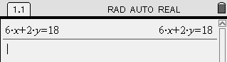
First type in the equation that you want to solve. Use the number pad and the green letter keys; the operations ( , , -, + ) are located on the right, and the equals sign ( = ) is in the top-left corner of the keypad. When you have typed in the equation, press the · key, found in the bottom-right corner.
The top of your screen will look something like this:
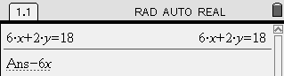
Now decide how you would start solving for y.
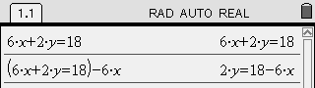
Perhaps you’ve decided that subtracting 6x from both sides of the equation is a good start. Wonderful! To do this, immediately press -6X. Notice that the handheld automatically inserts Ans . What is this?
Ans stands for the last answer you found. If you now press the · key, the handheld will subtract 6x from the left side and the right side of 6x + 2y = 18. You will see this result:
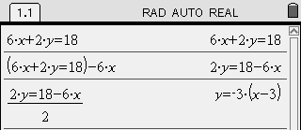
Continue solving the equation. You probably see that to finally isolate the y variable, it is necessary to divide the equation by 2 on both sides. Again, just start typing the operation you want to perform. Press p2. The handheld will insert Ans for you. Press · to calculate the result.
As you can see, the handheld reports that
y = -3(x-3) .
Is this the result you expected?
Your teacher will discuss this with your class.
After the discussion, use the space below to write your own explanation of what this means:
____________________________________________________________________________

____________________________________________________________________________

____________________________________________________________________________

____________________________________________________________________________

Nspire CAS Handheld Manual (Continued)

How to Check a Solution to a Linear System
Say that you have solved the following linear system:
and you believe the solution is .
This would be tedious to check by pencil and paper, but it is quick to check with the handheld.
Here is how to do it. First be certain that you are on a Calculator page. If you need help with this, see the Getting Started section from earlier in this manual.
You are going to press the following keys to check the solution against the first equation:
4X+2Y=24*X=9p2_AND_Y=3
This means: “Check this equation such that and .”
Don’t forget to press the _ key (lower-right corner of keypad) before and after the AND.
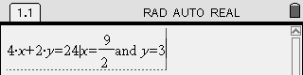
Here is what it will look like on your handheld screen:
To have the handheld check the solution, press the · key. If the solution is correct, the handheld will return the result “true”. If the solution is not correct, the handheld will report “false”.
You should find that the handheld reports that is a correct solution for the first equation.
Remember, it is necessary to check the solution in the second equation as well.
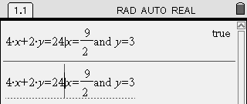
It works the same way as before, but you can save some typing! Use the circular “navpad” and press up twice. The first command you entered is highlighted. Now press the · key. The handheld copies the command down to the line you are working on. You can now use the navpad to move left until the cursor is behind the * symbol. It looks like this:
Press the . key to erase the first equation, then type the second equation. Then press ·.
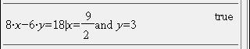
As you can see, is a correct solution for the second equation as well.
Since the solution is correct for both equations from the linear system, we know it must be the right answer.

Nspire CAS Handheld Manual (Continued)

How to Add or Subtract Two Equations
The elimination method for solving a linear system involves adding or subtracting the given equations.
Say that you are considering the following linear system:
You probably agree that if we add these two equations, the y variable will be eliminated.
Here is how to do this on a handheld. First be certain that you are on a Calculator page. If you need help with this, see the Getting Started section from earlier in this manual.
When you type in the equations, be certain to enclose them in brackets. Remember that we decided to add the equations. Here are the keys you should press:
(3X+2Y=16)+(5X-2Y=8)
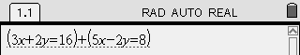
It will look like this on your handheld:

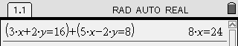
Press the · key. The handheld will display the result:
You have eliminated the y variable.
Subtracting two equations works the same way as adding two equations. The key is to remember that you must enclose each equation in brackets when you type it into the handheld.

How to Multiply to Find an Equivalent Equation
Consider the following linear system:
If we immediately add or subtract the equations, neither the x or the y variable is eliminated.
Instead, we must multiply one of the equations by an integer so that the coefficients match. Then, if we subtract the equations, a variable will be eliminated.
Let’s multiply the first equation by 3. Remember that all terms on both sides of the equation must be multiplied by 3, so that the equation stays balanced.
Here is how to do this on a handheld. First be certain that you are on a Calculator page. If you need help with this, see the Getting Started section from earlier in this manual. Press the following keys:
3r2X+3r-5Y=3r7

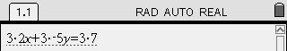
What you have typed should look like this:
Press the · key. The handheld will display the result:
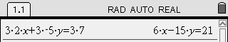
Now we have a system that we can begin to solve by subtracting the equations:

Installing TI-Nspire CAS Key Fonts - Teacher

In order to have the keys shown in your Word documents you need to download and install the Nspire Keys font on your computer. Here’s how:

Download the fonts:

- Go to www.education.ti.com.
- Select Downloads from the top of the screen.
- Go to the Key Fonts section and select TI-Nspire Key Fonts from the drop down box (you may have to scroll to the bottom).
- Click on the Download button.
- Click on TI-Nspire(tm) Key fonts for Windows(r). Make sure you know where you are saving the fonts (i.e. Desktop, My Documents, etc.).

Install the fonts:

- Go to the Control Panel on your computer. Most computers just require you to click on the start button and the control panel folder should be visible from the start menu.
- Open the Fonts folder by double-clicking on it.
- Go to the File Menu and Install New Font…
- You will now need to find the TINspireKeys font file. Once you find it, select it from the List of Fonts box and select OK.
- An easier way: Minimize all windows except the Fonts folder window. Reduce the size of this window so you can see the TINspireKeys font file on your desktop or in a folder and drag and drop it in the Fonts folder.

Unit 4 Day 1: Where Do We Meet? |  |  |  |  | Grade 10 Applied
Minds On: 15 Min. |  |  | Math Learning Goals  - Identify/Solve problems that arise from realistic situations that can be modelled by two linear relations.  - Determine graphically the point of intersection of two linear equations.  - Interpret the story the graph tells, including point of intersection and what occurs before and after the intersection point. |  | Materials  - BLM 4.1.1-4.1.3  - Chart paper  - Computer Algebra Systems (CAS)
Action: 45 Min.
Consolidate/
Debrief: 15 Min
Total = 75 Min.
Assessment
Opportunities
 | Minds On… | Small Groups à Guided Exploration  Introduce the idea of systems of equations by building on linear application problems from the previous unit (BLM 4.1.1).  Whole Class → Discussion  Summarize the idea of a Point of Intersection, or Solution to a System. |  |  | Divide class into homogeneous groups of at most 4 students per group.  Chart paper presentations should be evaluated to be aware of misguided understanding.
 | Action! | Pairs → Worksheet  Utilizing Think, Pair, Share, students interpret the system of equations application scenarios (BLM 4.1.2), connecting them to the appropriate equations, then discuss with the class.  Whole Class → Discussion  Ensure that all of the students have the scenarios and equations matched properly. Review the parts of y = mx + b, and how the words in the scenario matched the components of the equations. E.g., flat fee corresponds with ‘b’, the y-intercept.  Small Groups → Practice  Assign students a letter A through D, and then have them work in their letter group, attempting the problem associated with their letter. Students practice analyzing systems of linear equations, creating a table of values, plotting points, finding the point of intersection, and interpreting the meaning in the larger context of the problem (BLM 4.1.2). Afterwards they must recreate the graph on a sheet of chart paper and summarize their findings along with the questions.
 | Consolidate Debrief | Whole Class → Presentation  Each of the letter groups presents their findings and displays their chart paper graph.  Whole Class → Discussion  Discuss the similarities in the types of questions for Problems A, B, and C, and what makes Problem D different.
Reflection  Skill Drill |  | Home Activity or Further Classroom Consolidation  Assign BLM 4.1.3 as home activity and ask students to complete the following journal entry.  Journal: The equation of a vertical line is x = a and the equation of a horizontal line is y = b. Where will these lines intersect? Support your answer with an example that includes a graph.

4.1.1: Working on Commission

Nahid works at Euclid’s Electronics. She is paid a salary of $200 per week plus a commission of 5% of her sales during the week.
The equation $P=0\text{.}\text{05}s+\text{200}$, represents Nahid's pay for the week where P represents the total pay for the week and s represents her total sales.
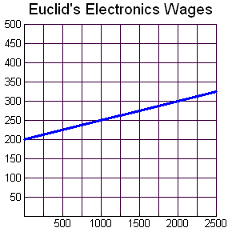
Week's Pay ($)
Total Value of Sales ($)
If Nahid earned $290 in a week use the equation to algebraically determine how much she sold.

Use your handheld to help you solve. Refer to the user manual if you need to review how to solve using the handheld.

Nahid is offered another job at Fermat's Footwear, where the pay is a salary of $100 per week and 10% commission on all sales. The graph below represents the Pay vs. Sales for this job.

Which of the following equations do you think represents pay for one week at Fermat's Footwear?
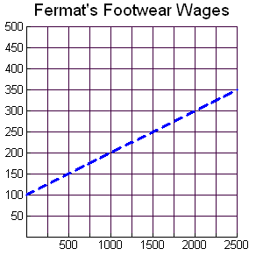
Week's Pay ($)
Total Value of Sales ($)
a) $P=0\text{.}\text{01}s+\text{100}$

b) $P=0\text{.}\text{10}s+\text{100}$

c) $P=\text{100}s+\text{10}$

d) $P=0\text{.}\text{05}s+\text{200}$

Provide a reason or justify why you selected
the equation that you chose. Refer back to
the equation for Euclid's Electronics for hints.

4.1.1: Working on Commission (Continued)
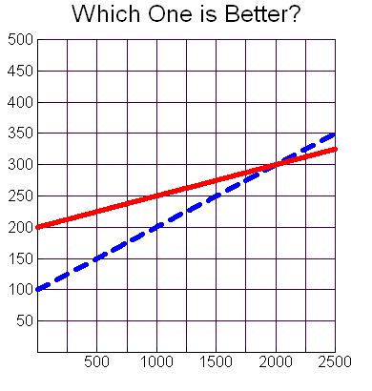
Total Value of Sales($)
Week's Pay ($)

Nahid needs help determining which job she should keep.
She decides to look at them as a system of equations when she creates a graph comparing the two equations at the same time.
Analyze the graph and complete the questions below.

_____ Euclid's Electronics

.…….. Fermat's Footwear

1. Where the two lines cross is called the point on intersection, or the solution to the system. At what coordinates do the two lines cross?

2. What does this coordinate represent in terms of Nahid's sales, and pay for the week?

3. If Nahid usually makes $1500 worth of sales per week, which job should she take? Explain.

4. How does the graph help Nahid determine which is the better job?

5. What does the point (1000, 250) represent in the graph?

4.1.2: What’s My Equation?

You are given four problems below. Each problem will require two equations to solve it. The equations that are needed to solve each problem appear at the bottom of the handout. Match the equations with the problems and compare your answers with another student.
Note: There are more equations than problems and all the equations use x for the independent variable and y for the dependent variable.

Problem A:  Yasser is renting a car. Zeno Car Rental charges $45 for the rental of the car and $0.15 per kilometre driven. Erdos Car Rental charges $35 for the rental of the same car and $0.25 per kilometre driven. Which company should Yasser choose to rent the car from? | Equations
Problem B:  The school council is trying to determine where to hold the athletic banquet. The Algebra Ballroom charges an $800 flat fee and $60 per person. The Geometry Hall charges a $1000 flat fee and $55 per person. Which location should the school council select for the athletic banquet? | Equations
Problem C:  The yearbook club is considering two different companies to print the yearbook. The Descartes Publishing Company charges a flat fee of $475 plus $4.50 per book. School Memories charges a flat fee of $550 plus $4.25 per book. Which company should the yearbook club select to print this year’s yearbook? | Equations
Problem D:  The school is putting on the play “Algebra: The Musical”. Adult tickets were sold at a cost of $8 and student tickets were sold at a cost of $5. A total of 220 tickets were sold to the premiere and a total of $1460 was collected from ticket sales. How many adult and student tickets were sold to the premiere of the musical? | Equations

EQUATIONS:
1. y = 4.50 + 475x | 2. 60 + 800x = y | 3. y = 1000 + 55x | 4. x = 45 + 0.15x
5. y = 1000x + 55 | 6. y = 45 + 0.15x | 7. x + y = 220 | 8. 5x + 8y = 220
9. y = 4.25x + 550 | 10. y = 550x + 4.25 | 11. y = 800 + 60x | 12. x + y = 1460
13. y = 0.25x + 35 | 14. y = 4.50x + 475 | 15. y = 35x + 0.25 | 16. 5x + 8y = 1460
4.1.2: What’s My Equation? (Continued)

Problem A:

Yasser is renting a car. Zeno Car Rental charges $45 for the rental of the car and $0.10 per kilometre driven. Erdos Car Rental charges $35 for the rental of the same car and $0.25 per kilometre driven. Which company should Yasser choose to rent the car from?

To solve the question, complete the table of values, and the graph.

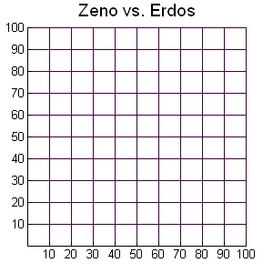
Cost ($)
Kilometers Driven
Zeno Erdos
Distance (km) | Cost
0
10
20
30
40
50
60
70
80
90
100

Distance (km) | Cost
0
10
20
30
40
50
60
70
80
90
100

1. How can the car rental cost and the cost per kilometre be used to draw the graph?

2. What is the point of intersection of the two lines? What does it represent?

3. Under what conditions is it best to rent from Zeno Car Rental?

4. Under what conditions is it best to rent from Erdos Car Rental?

4.1.2: What’s My Equation? (Continued)

Problem B:

The school council is trying to determine where to hold the athletic banquet. The Algebra Ballroom charges an $800 flat fee and $60 per person. The Geometry Hall charges a $1000 flat fee and $55 per person.
Which location should the school council select for the athletic banquet?

To solve the question, complete the table of values, and the graph.

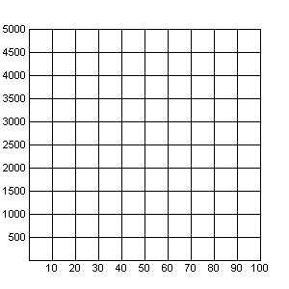
Cost ($)
Number of People
Algebra Ballroom vs. Geometry Hall
Algebra Ballroom Geometry Hall
Number of People | Cost
0
10
20
30
40
50
60
70
80
90
100

Number of People | Cost
0
10
20
30
40
50
60
70
80
90
100

1. How can the flat fee and the per person cost be used to draw the graph?

2. What is the point of intersection of the two lines? What does it represent?

3. Under what conditions is it best to go with Algebra Ballroom?

4. Under what conditions is it best to go with Geometry Hall?

4.1.2: What’s My Equation? (Continued)

Problem C:

The yearbook club is considering two different companies to print the yearbook. The Descartes Publishing Company charges a flat fee of $475 plus $4.50 per book. School Memories charges a flat fee of $550 plus $4.25 per book. Which company should the yearbook club select to print this year’s yearbook?

To solve the question complete the table of values, and the graph.

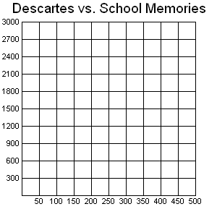
Cost ($)
Number of Books
Descartes
Number of Books | Cost
0
50
100
150
200
250
300
350
400
450
500

School Memories
Number of Books | Cost
0
50
100
150
200
250
300
350
400
450
500

1. How can the flat fee and the cost per book be used to draw the graph?

2. What is the point of intersection of the two lines? What does it represent?

3. Under what conditions is it best to go with Descartes Publishing?

4. Under what conditions is it best to go with School Memories?

4.1.2: What’s My Equation? (Continued)

Problem D:

The school is putting on the play “Algebra: The Musical”. Adult tickets were sold at a cost of $8 and student tickets were sold at a cost of $5. A total of 220 tickets were sold to the premiere and a total of $1460 was collected from ticket sales.
How many adult and student tickets were sold to the premiere of the musical?

To solve the question complete the table of values, and the graph.

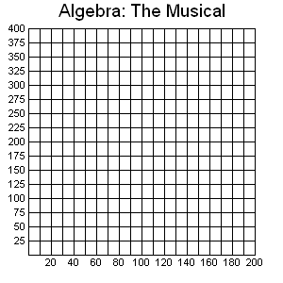
Let x represent the # of student tickets sold
Number of Student Tickets
Number of Adult Tickets
Let y represent the # of adult tickets sold

x | y
0
40
80
120
160
200

x | y
0
40
80
120
160
200

1. What is the approximate point of intersection of the two lines? What does it represent?

2. Does the rest of the graph (other than the POI) give us any information about the number of tickets sold?

4.1.3: Meaning of the Point of Intersection

1. Your family wants to rent a car for a weekend trip. Cars R Us charges $60.00 per weekend for a midsize car plus $0.20 per km. Travel With Us charges $0.50 per km.
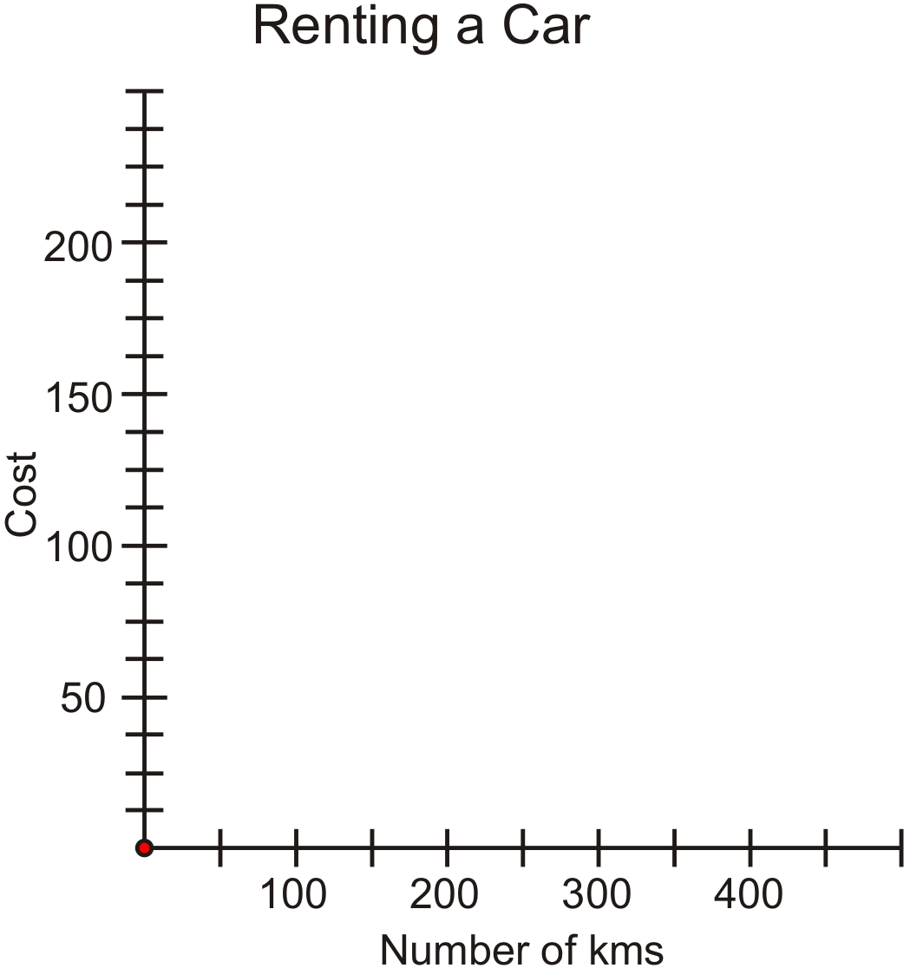
a. Graph both options on the grid and determine the number of kilometres where both companies will cost the same amount.
b. Explain what this means for your weekend trip.

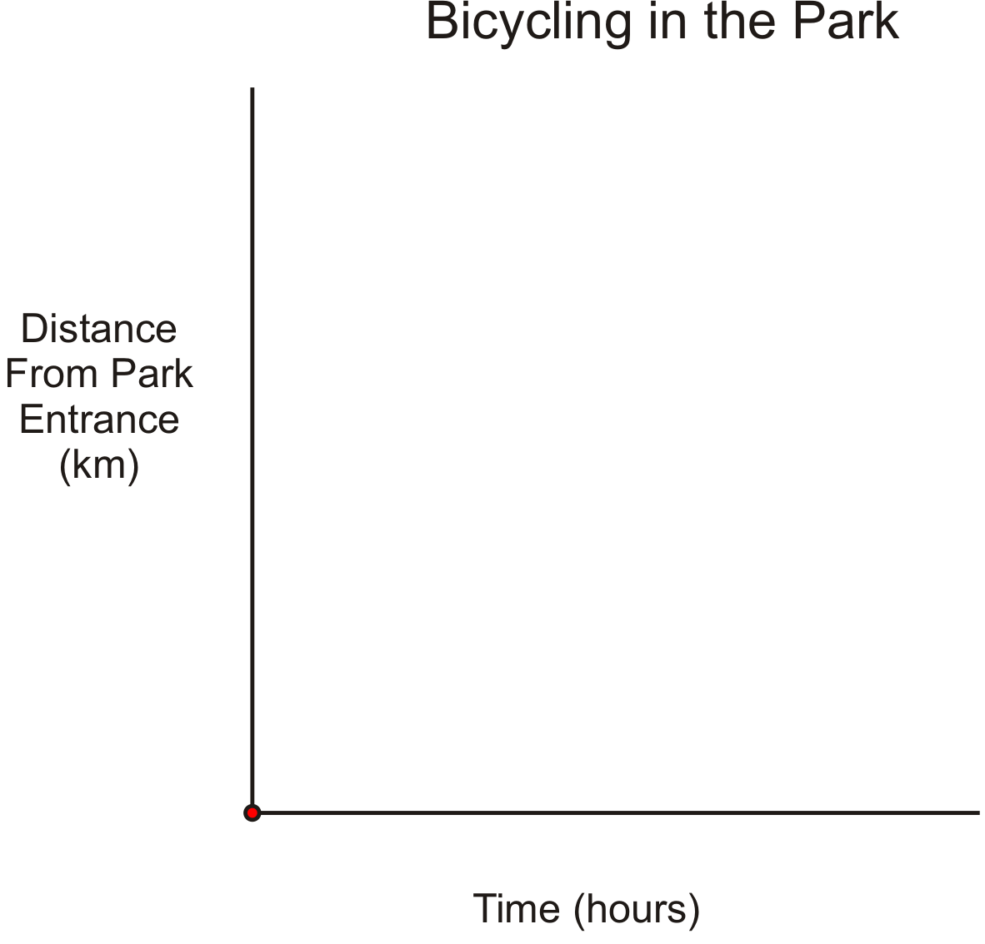
2. Anthony and Anne are bicycling at a Provincial Park. Anthony travels at the rate of 10 km/hr and begins 2 km from the park entrance. Anne begins at the park entrance and travels at a rate of 15 km/hr. They both travel at a constant rate towards the Outdoor Education Centre.
Graph both routes on the grid and determine the meaning of the point of intersection.

4.1.3: Meaning of the Point of Intersection (Continued)

3. For a car wash fundraiser Team A washes 2 cars per hour starting a 7:00 a.m.
Team B begins washing cars at 9:00 a.m. and washes 3 cars per hour.
Graph the car washing progress of each team on the grid and determine the meaning of the point of intersection, as well as the meaning of the points before and after the point of intersection.

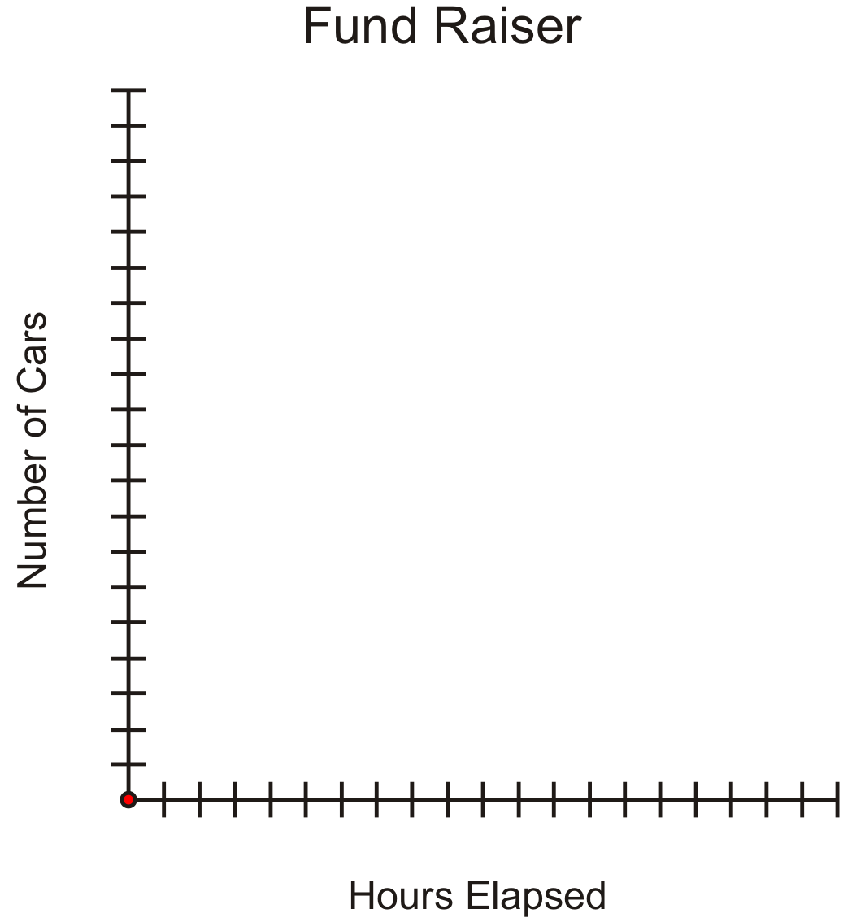

Unit 4 Day 2: What’s the Point? |  |  |  |  | Grade 10 Applied
Minds On: 15 Min. |  |  | Math Learning Goals  - Determine the coordinates of the points of intersection for pairs of linear relations given their graphs and interpret the meaning of the point of intersection.  - Solve a problem that arises from a realistic situation represented by two linear relations. |  | Materials  - BLM 4.2.1-4.2.5  - Computer Algebra Systems (CAS)
Action: 35 Min.
Consolidate/
Debrief: 25 Min
Total = 75 Min.
Assessment
Opportunities
 | Minds On… | Pairs → Worksheet  Utilizing Think, Pair, Share, students interpret the linear system (BLM 4.2.1), then discuss with the class. Stress the point that the solution depends on the conditions under consideration.
 | Action! | Whole Class → Guided Exploration  Represent graphically a situation that is modelled by a linear system. Students should understand the meaning of specific parts of the graph. e.g., point of intersection.  Demonstrate the graphical method of solving a linear system (BLM 4.2.2). Discuss the questions; emphasize the meaning of the point of intersection in terms of the problem.  Individual → Practice  Students practice analyzing systems of linear equations, finding the point of intersection, and interpreting the meaning in the larger context of the problem (BLM 4.2.3).
 | Consolidate Debrief | Pairs → Investigation  Through a series of graphing activities (BLM 4.2.4) student explore the point of intersection from different perspectives.  Whole Class → Discussion  As a class discuss the strategies used. Left Side Right Side verification is discussed as an alternative tool to graphing all of the lines to solve Questions 1 and 2. Students brainstorm as a class about Questions 3 and 5.
Concept Practice  Exploration |  | Home Activity or Further Classroom Consolidation  Solve the system of equations problems (BLM 4.2.5).

4.2.1: A Visual Cell Phone Problem

Two cell phone companies charge a monthly flat fee plus an additional cost for each minute of time used. The graph below shows the Time vs. Cost relationship, for one month.
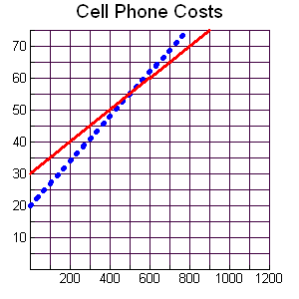
Time (minutes)
Cost ($)

____ Talk More

…… We Talk

1. What is the Point of Intersection (POI), and what is the meaning of the POI in relation to the cell phone plans?

2. Under what conditions is it best to use the Talk More cell phone plan?

3. Under what conditions is it best to use the We Talk cell phone plan?

4. How does the graph help you to determine which cell phone plan is the most appropriate at any given time?

4.2.2: Music is My Best Friend

iTones and Music Mine are two online music providers. Each company charges a monthly membership fee and then a per song download rate.

iTones charges $10 per month, and $1 per song $C=n+\text{10}$
Music Mine charges $7 per month and $1.50 per song. $C=1\text{.}5n+7$

Where C represents the total cost for one month and n represents the number of songs purchased.

Create a table of values showing the total charges for up to 8 songs purchased.
Graph the lines on the same graph below.

Number of Songs
Cost ($)

iTones

n | C
0
1

Music Mine

n | C
0
1

1. If Lulu plans to purchase 7 songs this month, which is the best plan for her? Explain.

2. Which plan is cheaper if you only plan to buy 4 songs per month? How do you know from the graph?

3. Which cell phone plan would you choose and why? Relate your answer back to the POI.

4.2.3: Where Do We Meet?

For each of the following situations, find the point of intersection and describe the meaning of this point. Describe which company or service you would choose under what circumstances. A template has been provided for the first situations.

Point of intersection:_____________

Interpretation of the point:

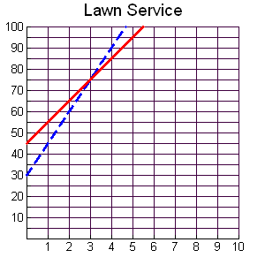
Cost ($)
Time (hours)
A
B
If the job lasts less than _____ hours, choose ______. If the job lasts more than ______ hours, choose _______.
If the job lasts _______ hours, choose either company and the cost is______
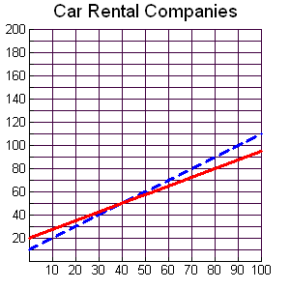
Cost ($)
Kilometers Driven
A
B

Point of intersection:_____________

Interpretation of the point:

If the kilometers driven is less than _____, choose ______. If the kilometers driven is more than ______, choose _______.
If the kilometers driven is _______, choose either company and the cost is______

4.2.3: Where Do We Meet? (Continued)

For each of the following situations, find the point of intersection and describe the meaning of this point. Refer back to the template provided for the first situations.

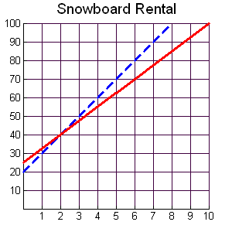
Cost ($)
Time (hours)
B
A

Point of intersection:_____________

Interpretation of the point:

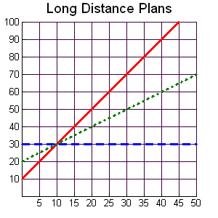
Cost ($)
Talking Time (hours)
A
B
C

Point of intersection:_____________

Interpretation of the point:

4.2.4: Does This Line Cross?

From the list of relations below, determine which lines cross through the point (2,3).
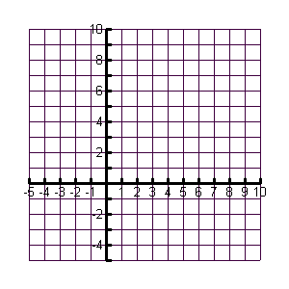
You may use the graph to assist you.
1. $y=2x+3$
2. $y=x+1$
3. $y=−2x+7$
4. $y=−3$
5. $x=2$
6. $y=2$

Questions:

1. Which of the lines passes through the point (2,3)?
2. Is there another way to determine if the line passes through the point, other than graphing? Explain.

3. Without graphing, how can you quickly determine if a horizontal or vertical line passes through a point?

4. Other than the point (2, 3), what are the other points of intersection on your graph?

5. Is it possible for two lines to have more than one point of intersection with each other? Discuss this with your partner.

4.2.5: Is this Accurate?

1. Find the point of intersection. (Solve the system using graphical method.)
a) y = 2x + 1  y = 3x – 2  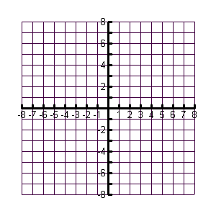  Point of intersection is :_______________ | b) y = -x -2  y = 2x + 7  Point of intersection is:________________
c) y = 2x + 1  y = 4x – 4  Point of intersection is :_______________ | d) y = -5  y = -3x+2  Point of intersection is :_______________

Unit 4 Day 3: Approximate or Accurate? |  |  |  |  | Grade 10 Applied
Minds On: 15 Min. |  |  | Math Learning Goals  - Discuss accuracy of solutions obtained through graphical means.  - Establish the need to isolate a variable in order to use the substitution method and practice the skill of isolating.  - Develop understanding of facility of solving systems using the substitution method to improve the accuracy of a solution. |  | Materials  - BLM 4.3.1-4.3.5  - Computer Algebra Systems (CAS)
Action: 50 Min.
Consolidate/
Debrief: 10 Min
Total = 75 Min.
Assessment
Opportunities
 | Minds On… | Pairs → Investigation  Distribute BLM 4.3.1 to each student. Students are to work in pairs. One student in each pair is to solve one of the problems. Students are to then exchange solutions and provide feedback to each other regarding their solution. Write the heading “System A” and “System B” on the board chart paper or overhead transparency. Students are to write their solution to each system under the appropriate heading.  Whole Class → Discussion  Discuss the solutions provided to each system. Ask for reasons as to why their solutions are not exactly the same. The goal is to draw out the approximate nature of the solutions and that this is one of the disadvantages of solving systems graphically. |  |  | Students are encouraged to use CAS to check their solutions. They will probably get a “false” statement returned which should reinforce the approximate nature of their solution.  Students can use CAS to solve their equations using an explicit method (not using the SOLVE command).  If an overhead projector is not available, use scrap paper with the individual pieces of both equations written on each piece of paper and post on the board or use the movie file “Method of Sub_Intro” that demonstrates the process. Note: The process is narrated in the file.  Students are to identify which is cheaper before the point of intersection (lower flat fee) and which is cheaper after (lower rate of change).
 | Action! | Individual → Worksheet  Distribute BLM 4.3.2 to each student. Students are to solve these “simple” systems algebraically and note which equation they solve first in each equation and why they chose that equation. The goal is to stress that they can only solve equations that are expressed in a single unknown.  Whole Class → Demonstration  Using BLM 4.3.3, display the first system on an overhead projector. Ask the class to identify what is different about the system they see on the overhead projector from the ones that they were able to solve on BLM 4.3.2. Stress student responses that highlight the fact that both equations now have two unknowns. Note: The first system is one of the systems they solved in the Minds On (BLM 4.3.1 System B).  To solve the system, lead the class in demonstrating the method of substitution by cutting the overhead along the dotted lines and physically replacing the “y” in the second equation with the expression “2x + 7” from the first equation. Ask students why this is correct mathematically.  Distribute BLM 4.3.3 (Student Worksheet) and ask students to solve the resulting equation. Repeat this process using the second system on BLM 4.3.3. Note that in the second system we could isolate either x or y.  Small Groups → Worksheet  Using BLM 4.3.4, in groups of three, each student solves one of three systems. The point of intersection for each is: System A (-4, 8); System B (0, -4); System C (2, -10). The three points are collinear. The students are to determine the equation of the line connecting all three. The correct equation is y = -3x – 4.
 | Consolidate Debrief | Small Groups → Worksheet  Distribute BLM 4.3.5 to students. Each group is to divide the three problems among the group members and solve them using substitution and then complete the questions on the reverse of the handout. The goal is to identify for what types of problems the method of substitution is preferable to solving by graphing (i.e. approximate solutions and/or values for graphing are to large for practical solution).
Concept Practice  Reflection |  | Home Activity or Further Classroom Consolidation  Journal: Dillon was absent for today’s lesson. Explain to him how to find the point of intersection between 4x - y = 7 and 6x + y = 13. Provide a detailed explanation of each step.  Assign concept practice questions.

4.3.1: What’s my POI?

- Each one of you will solve one of the systems of equations given below.
- Once you have solved the system you were assigned, trade with your partner and check their solution. Share your feedback with your partner.
- Once you have shared your feedback and are confident in the solutions to the systems, post your point of intersection under the appropriate heading on the class list.

System A | System B
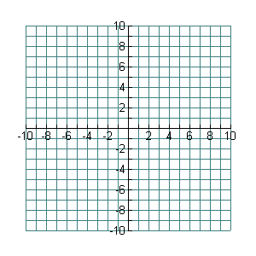  Point of Intersection: ( , ) | Point of Intersection: ( , )

4.3.2: A Better Way

Solve the following systems of equations algebraically. Use your CAS handheld to solve and check if needed.

- Equation 1: y + 2 = 10 and Equation 2: x + y = 12

Point of intersection: (____, ____)

- Equation 1: 3x + 2y =33 and Equation 2: 2x = x + 7

Point of intersection: (____, ____)

In each of the systems you solved above, which equation did you choose to solve first? Why did you select that equation in each case?

4.3.3: Putting the Pieces Together – Teacher Demonstration

y | = | 2x | + | 7 | and | y | = | -3x | + | 4

-2x | + | y | = | 0 | and | x | - | y | = | 12

4.3.3: Putting the Pieces Together – Student Worksheet

System 1: y = 2x + 7 and y = -3x + 4

Record the line that results once you have substituted, and then solve the equation using your CAS handheld.

Resulting equation and my solution. (Don’t forget to solve for both variables.)
Check your solution using the CAS handheld.
Compare your solution to someone else in the class.

System 2: -2x + y = 0 and x - y = 12

Record the line that results once you have substituted, and then solve the equation using your CAS handheld.

Resulting equation and my solution. (Don’t forget to solve for both variables.)
Check your solution using the CAS handheld.
Compare your solution to someone else in the class.

4.3.4: The “Sub” Way

- In groups of three, have each person in the group solve one of the systems below.
- Use your CAS handheld to help you solve and check your system.
- Share your solutions with each person in the group.

System A | System B
y = 4x + 24 and y = -5x – 12 | 13x + y = – 4 and 5x + y + 4 = 0
System C | Challenge
y = -x – 8 and y = -5x | CHALLENGE: Plot each of the POI's from Systems A, B, and C and find the equation of the line that connects the three points.  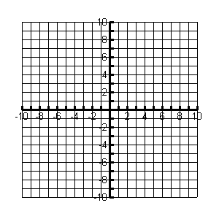  Equation of Line:_____________________

4.3.5: What’s My Equation? - Part 2

Part A
Let’s return to our application problems that we solved graphically earlier in the unit. Assign each person in your group one of the three problems to solve. Solve these application problems using the method of substitution introduced today. Use the CAS handheld to help you solve.

Problem A:  Yasser is renting a car. Zeno Car Rental charges $45 for the rental of the car and $0.15 per kilometre driven. Erdos Car Rental charges $35 for the rental of the same car and $0.25 per kilometre driven. For what distance do the two rental companies charge the same amount? | Equations  y = 45 + 0.15x  y = 35 + 0.25x
Problem B:  The school council is trying to determine where to hold the athletic banquet. The Algebra Ballroom charges an $800 flat fee and $60 per person. The Geometry Hall charges a $1000 flat fee and $55 per person. For what amount of guests do the two banquet halls charge the same amount? | Equations  y = 60x + 800  y = 55x + 1000
Problem C:  The yearbook club is considering two different companies to print the yearbook. The Descartes Publishing Company charges a flat fee of $475 plus $4.50 per book. School Memories charges a flat fee of $550 plus $4.25 per book. For what amount of books do the two companies charge the same amount? | Equations  y = 475 + 4.50x  y = 550 + 4.25x
____________________________________________________________________________

I am solving problem ___:
4.3.5: What’s My Equation? - Part 2 (Continued)

Part B
Discuss the following questions with your group members.

- Looking at your problem, how can you tell from the equation which company is cheaper before the point of intersection (where the costs are equal)?

- Looking at your problem, how can you tell from the equation which company is cheaper after the point of intersection (where the costs are equal)?

- Is this true for all problems?

- Now that you’ve solved the problems using two different methods, which method do you prefer? Why?

- When do you think solving by substitution would be preferable to solving by graphing?

Unit 4: Day 4: The SubMathiner |  |  |  | Grade 10  Applied
Minds On: 10 |  | Math Learning Goals:  - Determine the conditions for which a linear relation application is preferred to the algebraic models by comparing the rate of change and initial value of two linear relations making up a system of equations.  - Identify which variable is the most efficient for isolating and then solve linear systems using the method substitution. |  | Materials  - BLM 4.4.1-4.4.4  - Scissors  - Glue  - Computer Algebra Systems (CAS)
Action: 55
Consolidate:10
Total=75 min
Assessment
Opportunities
 | Minds On… | Individual → Worksheet  Distribute BLM 4.4.1 to each student. Students are to complete the solution to the contextual problem as a review of solving by substitution.  Optional: Discuss the home activity assigned in yesterday’s class to consolidate the algorithm for solving by substitution. |  | Refer back to the graphical solution of this problem and connect the appropriate region of the graph with the appropriate part of the solution.  Students will need scissors and glue for this portion of the lesson.
 | Action! | Pairs → Kinesthetic Activity  Distribute BLM 4.4.2 and a blank piece of paper to each pair of students. Students are to cut the boxes necessary for the solution of the system at the top of the handout and glue them on the blank piece of paper. Once they have completed their solution, they are to compare their solution with another pair of students.  Whole Class → Discussion  Ask students what is different in solving this system from the systems they were solving the previous day. Highlight the need to distribute once they have substituted in the expression.  Small Groups → Investigation  Distribute BLM 4.4.3 to each student. After students respond to #1, highlight the importance of identifying which variable it is easiest to isolate for when using substitution. Students will complete the solution to one of the three systems provided. The solution to all three systems is (-1, 2). Check to see that students understand that as long as a system has values that follow an arithmetic progression, the solution to the system will be (-1,2). Discuss as a class the second equations created in question #7 to ensure that everyone has the correct systems as these will be assigned for students to complete for their home activity.
 | Consolidate Debrief | Pairs → Worksheet  Distribute BLM 4.4.4 to each student. Students are to write the algorithm for solving by substitution using the text boxes provided and then solve the system as model of solving by substitution.  Whole Class → Discussion  Discuss correct order of steps for solving by substitution.
Skill Practice |  | Home Activity or Further Classroom Consolidation  Complete the systems created in question #7 from BLM 4.4.3.

4.4.1: The Lowdown on Downloads

Let’s return to our music downloading problem. Here’s the problem again.

iTones and Music Mine are two online music providers. Each company charges a monthly membership fee and then a per song download rate.

iTones charges $10 per month, and $1 per song $C=x+\text{10}$
Music Mine charges $7 per month and $1.50 per song. $C=1\text{.}5x+7$

- Find the number of songs that I would need to download where the costs are the same for the two music providers.

- Paris solved the problem and then made the following conclusion:
If you download less than 6 songs per month than choose iTones since the cost per song is less. If you download more than 6 songs per month than choose Music Mine since the fixed cost is less. If you download exactly 6 songs per month, choose either music provider.

Is the conclusion that Paris made correct? If not, underline the part(s) of her conclusion that are incorrect and then rewrite it so that it is correct.
4.4.2: Putting the Pieces Together

Solve the system: y = 10 – 2x and x – 2y = 10

The solution to this system is given in the pieces below. Cut the pieces out and glue them in the correct order on a separate piece of paper. Use the handheld to help you. Hint: There are 10 steps in the complete solution.


x – 2(10 – 2x) = 10
x – 10 – 2x = 10
5x = 10 + 20
5x = 30
x = 30/5
x = 6
y = 10 – 2(6)
y = 10 – 12
y = -2
Point of Intersection: (6,-2)
Point of Intersection: (-2,6)
x – 20 – 4x = 10
–x = 10 + 10
–x = 20
x = -2
y = 14

x = -20
x – 20 + 4x = 10

4.4.2: Putting the Pieces Together – Solution (Teacher)

Solve the system: y = 10 – 2x and x – 2y = 10

The solution to this system is given in the pieces below. Cut the pieces out and glue them in the correct order on a separate piece of paper. Use the handheld to help you. Hint: There are 10 steps in the complete solution.

x – 2(10 – 2x) = 10
5x = 10 + 20
5x = 30
x = 30/5
x = 6
y = 10 – 2(6)
y = 10 – 12
y = -2
Point of Intersection: (6,-2)
x – 20 + 4x = 10

4.4.3: An Interesting Problem

Consider the following three systems of equations:

System A | System B | System C
x + 2y = 3 and 4x + 5y = 6 | -2x + y = 4 and 7x + 10y = 13 | -5x – 3y = -1 and x + 3y = 5

- In order to solve these systems by substitution, we need to first isolate one variable in one equation. Circle the variable in each system that would require just one step to isolate. Compare your choice with a neighbour.

- Using your handheld to help you, isolate the variable you selected in #1 for each system.

System A | System B | System C

- Assign each system to one person in your group and solve the system assigned to you in the space below. Use your handheld to help solve and check.

I am solving system _____:

Point of Intersection (_____, _____)

- Compare your solution to the rest of the group. What do you notice?

4.4.3: An Interesting Problem (Continued)

- The chart below lists out only the numbers that appear in each system. What do you notice about the numbers in each system?

System A | System B | System C
1, 2, 3, 4, 5, 6 | -2, 1, 4, 7, 10, 13 | -5, -3, -1, 1, 3 , 5

- Let’s see if this works with more systems. Each system below has only one equation given. Assign each system to one person in the group and create a second equation that will give the solution (-1, 2) when solved.

System A | System B | System C
Equation 1: x + 6y = 11  Equation 2: ____________ | Equation 1: -14x – 9y = -4  Equation 2: ____________ | Equation 1: 9x + 7y = 5  Equation 2: ____________

- Share your equation with everyone in the group and copy down the equations from the rest of the group. Review the equations created and make sure they follow the rule that you noted in #5. You will solve these three systems as a part of your home activity.

4.4.4: The Sub Steps

Solving using the method of substitution requires five steps. The steps are given below in the text boxes. Discuss with your partner what you think the correct order is for the steps and then write the steps in the space provided. Solve the system in the chart as model of solving by substitution. Check using your handheld.
State the point of intersection.
Solve the resulting equation.

Substitute the isolated expression into the other equation.
Substitute your solution into an original equation to solve for the other variable.

Isolate for a variable. The easiest variable to isolate for has a coefficient of 1.

Steps for Solving by Substitution | Example: Solve  4x + y = 6 and 2x – 3y = 10

Unit 4 Day 5: There Is Another Way! |  |  |  |  | Grade 10 Applied
Minds On: 15 Min. |  |  | Math Learning Goals  - Identify situations where the solving by substitution is not efficient.  - Identify necessary conditions or “look-fors” that make solving by elimination possible.  - Develop the algebraic method of solving a system by elimination. |  | Materials  - BLM 4.5.1- 4.5.4.  - Computer Algebra Systems (CAS)
Action: 45 Min.
Consolidate/
Debrief: 15 Min
Total = 75 Min.
Assessment
Opportunities
 | Minds On… | Pairs > Investigation  Students are given a contextual problem (BLM 4.5.1) to be solved by substitution, using Think, Pair, Share. Discuss issues that occur when they try to solve the problem. Lead students to the conclusion that we need a better way to solve this system.
 | Action! | Pairs > Worksheet  Distribute BLM 4.5.2. Students add and subtract equations in a given set of linear systems. Identification of what operation (+/-) will eliminate a variable. Develop necessary conditions for elimination.  Whole Class > Guided Example  Reinforce the elimination algorithm for students using BLM 4.5.3.  Whole Class > Kinesthetic Activity  Using BLM 4.5.4, students find their 'elimination partner' who has an equation suitable for eliminating a variable by addition or subtraction. Each equation will have only one suitable match. Checks for student understanding of the conditions necessary for elimination.
 | Consolidate Debrief | Individual > Practice  Students return to the contextual problem discussed in the Minds On (BLM 4.5.1) and solve by elimination. Students to check their solution using CAS.  Whole Class > Discussion  Compare ideas on conditions necessary for elimination.
Reflection |  | Home Activity or Further Classroom Consolidation  Students create three sets of equations in which one variable could be eliminated.

4.5.1: A Trip to Jim Hortons – Teacher Notes

In question 1, encourage students to develop equations to represent the context given.

This will help students prepare for the summative task in this unit.

The linear system that describes the context:

… is designed to be problematic when solved by substitution, but simple to solve by elimination.

When solving by substitution, students will note that upon re-arranging to solve for a variable, fractional coefficients and/or repeating decimals are encountered.

4.5.2: An Elimination Introduction – Notes to Teacher

After discussing the introduction to this section, you may wish to have your students go through the “How to Add or Subtract Two Equations” section of the CAS manual included at the beginning of this unit file.
The purpose of this exercise is for students to understand that adding and subtracting equations can eliminate a variable. After completing the exercise students should be able to identify what conditions are necessary for elimination to occur when adding, and what conditions are necessary for elimination to occur when subtracting.
The use of the CAS on the handheld is encouraged to allow a student to complete this exercise even if their algebra skills are not at grade level.

4.5.3: Solving a Linear System by Elimination – Teacher Notes

Guide students to a solution for the system. Use of CAS is encouraged so that students with algebra skills that are below grade level are still able to learn the elimination algorithm.
Students to describe in their own words the steps required to solve a linear system by elimination after guided example. Show students how to check a solution to a linear system using CAS on the handheld (see CAS manual at the beginning of the unit file).
4.5.1: A Trip to Jim Hortons

It’s summer vacation. Ah, sweet freedom. The only problem is that you’re the designated coffee gopher at the office where you have a summer job. On Monday, you were sent out to Jimmies to pick up five small coffees and seven extra large coffees. You remember that the total cost was $14.95, including tax. On Tuesday, you were sent out to get three small coffees and seven medium coffees. You recall that the total came to $12.75, with tax.

It’s Wednesday morning and your coffee crazy co-workers are calling for their cup o’ joe. Unfortunately, since the morning fix hasn’t arrived yet, no one can remember how much a small or extra large coffee costs, including yourself. You need to find out how much each size costs to collect the correct amount of money for the Wednesday coffee run.

- Let $s$ be the number of small coffees ordered on a single day.
Let $e$ be the number of extra large coffees ordered on a single day.
As a class, can we decide on an equation to represent the purchases made on Monday, and an equation to represent the purchases made on Tuesday?
Monday’s equation: ___________________________________________________
Tuesday’s equation: ___________________________________________________
- Now we have a linear system. Take a few minutes to solve the linear system using substitution in the space below. Then pair with another student to discuss your solution.
- What problems, if any, did you encounter?

4.5.2: An Elimination Introduction

You know that two integers can be added, or subtracted:

In the same way, equations can be added, or subtracted:

Notice that by adding the equations in the first linear system, the variable was eliminated (there were 0y), which makes it possible to solve for .

By subtracting the equations in the second linear system, the variable was eliminated (there were 0x), which makes it possible to solve for .

- Work in pairs to consider the following linear systems. Decide what operation – addition or subtraction – would result in the elimination of a variable. You may use CAS on the handheld to help you decide.
- What needs to be true about a linear system so that a variable is eliminated when the equations are added or subtracted?

4.5.3: Solving a Linear System by Elimination

- How would you begin solving this linear system? Addition or Subtraction?
- Solve the system.
- In your own words, describe what you must do to solve a linear system by elimination.
________________________________________________________________________
________________________________________________________________________
________________________________________________________________________
________________________________________________________________________
________________________________________________________________________
________________________________________________________________________
________________________________________________________________________
________________________________________________________________________

4.5.4: Find Your Elimination Partner - Set of Systems (Teacher)

Give each student in your class an equation. Matching equations are organized here beside each other. Students to move around room and find their elimination partner, then solve the system together and check the solution using CAS on the handheld. Solutions for teacher reference included at right. Each equation works only with it’s partner as shown in the table below. Once they have found their partner, have them work together to solve. They may use CAS to check the solution.

6x + 4y = 12 | 6x − 9y = 51 | (4,-3)
4x – 3y = -10 | 2x + 3y = 22 | (2,6)
5x + 2y = -11 | x + 2y = -7 | (-1, -3)
7x + 13y = 72 | 7x – y = -194 | (-25, 19)
18x - 11y = 360 | 13x - 11y = 315 | (9,-18)
11x + 15y = 204 | 8x + 15y = 222 | (-6,18)
9x + 5y = 173 | 2x + 5y = -86 | (37,-32)
10x + 30y = 60 | -10x + 20y = 40 | (0, 2)
12x + 18y = 36 | 12x + 12y = -36 | (-15, 12)
48x + 16y = 48 | 16x + 16y = -16 | (2, -3)

Unit 4 Day 6: There Is Another Way! – Part II |  |  |  |  | Grade 10 Applied
Minds On: 15 Min. |  |  | Math Learning Goals  - Determine that an equation multiplied by a constant is equivalent to the original equation.  - Develop a complete algorithm for the algebraic method of elimination to solve a linear system.  - Solve problems using the method of elimination that arise from realistic situations described in words. |  | Materials  - BLM 4.6.1-4.6.6  - Computer Algebra Systems (CAS)  - Six overhead marker; multiple colours suggested.
Action: 45 Min.
Consolidate/
Debrief: 15 Min
Total = 75 Min.
Assessment
Opportunities
 | Minds On… | Small Groups > Guided Exploration  Divide class into groups of four students. Display graph of points from the equation x + 2y = 6 on an overhead. Each group is then given a constant to multiply this equation by. Groups create a table of values for their new equation, and plot the points on an overhead copy of BLM 4.6.1. Each group’s sheet is then placed over the original plot shown. Students will see that their “new” equations are equivalent to the original. Ask students to comment on what they observe as each group places their graph over the original transparency. |  |  | Make five copies of BLM 4.6.1 on an overhead transparency. Select constants from the group 2, 4, 8, 12, and 20.
 | Action! | Whole Class > Guided Example  Distribute BLM 4.6.2. Students use what they have observed from the Minds On to modify a linear system such that a variable will be eliminated by addition or subtraction.  Pairs > Worksheet  Distribute BLM 4.6.3. Using Think, Pair, Share, return to an earlier example from this unit and solve by elimination. One half of class instructed to eliminate x variable, the other half instructed to eliminate y variable. Discuss why the decision to eliminate one variable first as opposed to another does not change the solution.  Individual Practice > Worksheet  Using BLM 4.6.4, students solve two linear systems based on contextual examples.
 | Consolidate Debrief | Pairs > Reflection  Distribute BLM 4.6.5. Given a question, students are asked to write a summary of the steps necessary to solve by elimination.  Whole Class > Discussion  Introduce the performance task to students. Students will be asked to develop a context, include a linear system that describes the context, and then solve the linear system, by graphing, and by the students’ choice of substitution or elimination.
Concept Practice  Skill Drill |  | Home Activity or Further Classroom Consolidation  Using BLM 4.6.6, provide practice with questions that have parallel and coincidental solutions.

4.6.1: What’s the difference?

Original equation: $x+\text{2y}=6$

Multiply the equation by the constant ______. The new equation is _____________________.

Complete the table of values for your equation and plot the values on the grid provided.

x | -4 | -2 | 0 | 2 | 4
y

4.6.2: Elimination Preparation

- Consider the following linear system:
$\begin{aligned}\text{ 3k}+\text{15m}=\text{ 15} \\ −\text{ k}−\text{ m}\text{=-}1\end{aligned}$
If you add or subtract the equations, will a variable be eliminated? Explain.
- What could be done to create the conditions necessary for elimination?

4.6.3: Algebra, the Musical, Redux

Recall that in the first lesson of this unit, you solved the following problem by graphing:

The school is putting on the play “Algebra: The Musical”. Adult tickets were sold at a cost of $8 and student tickets were sold at a cost of $5. A total of 220 tickets were sold to the premiere and a total of $1460 was collected from ticket sales.
How many adult and student tickets were sold to the premiere of the musical?

If $x$ represents the number of student tickets sold, and $y$ represents the number of adult tickets sold, then the equations that model this problem are:

(from cost of tickets) $\text{5x}+\text{8y}=\text{1460}$
(from number of tickets sold) $\text{ x}+y=\text{ 220}$

You probably remember that this problem took a while to solve by graphing, and the answer you found was not necessarily very accurate, since you read the point of intersection off of the graph.
You will work with a partner now to solve this problem using the method of elimination.

- Since you have been asked to eliminate the x or y variable (circle one) first, what will be the first step you take to create the conditions necessary for elimination?
- Solve the linear system now. You may use CAS to help find the answer and check the solution. Use the space below for rough work.
- Does it matter which variable is eliminated first? That is, does it change the final answer?
- Think back to when you solved this problem by graphing. Do you find the method of elimination easier or harder? Explain.

4.6.4: Two for You

Try solving the following questions using the method of elimination. You may use CAS on the handhelds to help solve the questions and check your solutions.

- A fitness club charges an annual fee and an hourly fee. In a single year, member A worked out for 76 hours and paid $277 in total. Member B worked out for 49 hours and paid $223 in total. What is the annual fee? What is the hourly fee?
HINT: Start by writing “let” statements to define the variables you will use. For example:
Let a represent the amount of the annual fee.
Let h represent the amount of the hourly fee.

- This past summer, you ran a food booth at a local festival. You sold hotdogs for
$1 each and samosas for $2.50 each. From 205 purchases, you made $400 in total. To help plan purchases for next year’s festival, you’d like to know how many hotdogs and samosas were sold. Unfortunately, you forgot to keep track of this when selling the food. Can you determine how many hotdogs and samosas were sold?
NOTE: Assume one hotdog or one samosa per purchase.

4.6.5: Help an Absent Friend

Consider the following linear system:

$$\begin{aligned}\text{2x}+\text{3y}=1 \\ \text{3x}−\text{y }=7\end{aligned}$$

How would you solve it? Write in words a description of the steps you would take.

To help you understand what to write, pretend for a moment that you are writing the instructions for a friend who is not in class today. What steps would you need to describe?

4.6.6: “Here’s To The Crazy Ones”

- Solve the following linear system by elimination:
$\begin{aligned}\text{4x}+\text{2y}=\text{12} \\ \text{8x}+\text{4y}=\text{32}\end{aligned}$
- Did you encounter any results that are unusual? Explain what is different compared to questions you have already solved.
- Re-arrange each equation from the linear system into $y=\text{mx}+b$ form, then graph.
For example, here is how the first equation can be re-arranged:
$\begin{aligned}\text{4x}+\text{2y}=\text{12} \\ \text{2y}\text{=-}\text{4x}+\text{12} \\ \frac{\text{2y}}{2}=\frac{−\text{4x}}{2}+\frac{\text{12}}{2} \\ y\text{=-}\text{2x}+6\end{aligned}$
- What do you notice about the slope in each equation that you re-arranged? What do you notice about how the two lines visually relate to each other? Is there a solution to this linear system?

4.6.6: “Here’s To The Crazy Ones” (Continued)

- Solve the following linear system by elimination:
$\begin{aligned}\text{ 6x}+\text{2y}=2 \\ \text{12x}+\text{4y}=4\end{aligned}$
- Did you encounter any results that are unusual? Explain what is different compared to questions you have already solved.
- Re-arrange each equation from the linear system into $y=\text{mx}+b$ form, then graph.
- What do you notice about the slope and y-intercept in each equation that you re-arranged? What do you notice about how the two lines visually relate to each other? Is there a solution to this linear system? If so, how many?
Unit 4 Day 7: Which One is Best? |  |  |  |  | Grade 10 Applied
Minds On: 20 Min. |  |  | Math Learning Goals  - Identify necessary conditions or “look-fors” in a system of equations that make it best suited to be solved by graphing, substitution or elimination.  - Solve a system of equations using two of the three methods.  - Solve a system of linear equations using the most appropriate method. |  | Materials  - BLM 4.7.1-4.7.5  - Computer Algebra Systems (CAS)
Action: 35 Min.
Consolidate/
Debrief: 20 Min
Total = 75 Min.
Assessment
Opportunities
 | Minds On… | Whole Class → Kinesthetic Activity  Teacher explains the 4 Corners activity and indicates that signs are in each corner representing the methods of Graphing, Substitution, Elimination, and Not Sure (BLM 4.7.1). The teacher then puts up the overhead (BLM 4.7.2) displaying the first set of equations. Students must go to the corner with the method that they believe is the best method for solving. Each corner must justify their method choice. Work through the three sets of equations.  Whole Class → Discussion  The overhead displaying all of the 4 Corners questions is displayed. Students are asked to match the three sets up with one of the methods, and they can only use each method once. E.g, System 1 is best suited to elimination. System 3 could be graphing or substitution, but substitution is best used for System 2, therefore System 3 is graphing. Discuss what aspects make a system of equations best suited to a certain method. |  |  | Assign Frayer model as an assignment to be submitted next class
 | Action! | Pairs → Worksheet  Utilizing Think, Pair, Share, students must solve the three sets of equations, choosing one of them to solve using two methods (BLM 4.7.3).  Whole Class → Guided Exploration  Take up the three sets of questions by having students put their solutions on the board using as many methods as are appropriate. Discuss the key aspects again for selecting a method.
 | Consolidate Debrief | Small Groups → Model Making  Students work in groups of three to complete a Frayer Model (BLM 4.7.4) on one of the Graphing, Substitution, or Elimination methods.
Application  Concept Practice |  | Home Activity or Further Classroom Consolidation  Students practice solving using multiple methods, and identifying the best method (BLM 4.7.5)  Remind students to start thinking about ideas for summative, where they must create their own ‘real-life’ question with systems of equations.

4.7.1: Four Corners

NOT SURE

4.7.1: Four Corners (continued)

GRAPHING

4.7.1: Four Corners (continued)

SUBSTITUTION

4.7.1: Four Corners (continued)

ELIMINATION

4.7.2: Which Method?

$2x+3y=\text{10}$ System A
$$−4x+5y=2$$
____________________________________________________

$y=x−2$ System B
$$x+5y=−4$$
______________________________________________

$y=2x−7$ System C
$$y=−4x+5$$

4.7.3: Which Method? (Continued)

For System A determine if you can solve the system using each of the three methods you have learned, and if you can, then solve.  $$2x+3y=\text{10}$$  $$−4x+5y=2$$  Justify why you can or cannot solve using this method. | Graphing:  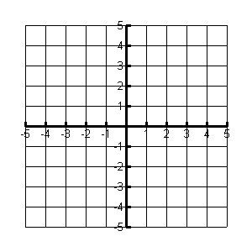  Justification:
Substitution:  Justification: | Elimination:  Justification:

4.7.3: Which Method? (Continued)

For System B determine if you can solve the system using each of the three methods you have learned, and if you can, then solve.  $$y=x−2$$  $$x+5y=−4$$  Justify why you can or cannot solve using this method. | Graphing:  Justification:
Substitution:  Justification: | Elimination:  Justification:

4.7.3: Which Method? (Continued)

For System C determine if you can solve the system using each of the three methods you have learned, and if you can, then solve.  $$y=2x−7$$  $$y=−4x+5$$  Justify why you can or cannot solve using this method. | Graphing:  Justification:
Substitution:  Justification: | Elimination:  Justification:

4.7.4: The Frayer Model

Definition | Facts/Characteristics
Examples | Non-Examples

4.7.5: 3 Ways

Two catering companies provide food and the banquet hall for weddings, proms and anniversaries. Nick and Heather are getting married in September and they have two catering companies to choose from:

Cookie’s Catering  Cesaer Salad  Chicken Picatta  Roasted Potatoes  Steamed Vegetables  Sherbert  Coffee or Tea | Frugal Gourmet  Minestrone Soup  Mixed green salad  Prime Rib  Garlic Mashed Potatoes  Asparagus  Apple Pie  Coffee or Tea

The cost(C) for the different menu options includes the cost of the hall rental and price per person(n).  Cookie’s Catering: C= 40n+500  Frugal Gourmet: C=45n+350  Cookie’s Catering Frugal Gourmet | Solve the system using the graphing method:  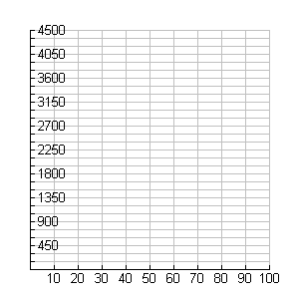  Point of intersection:_________________

4.7.5: 3 Ways (Continued)

Solve the system using substitution  Point of intersection:_______________ | Solve the system using elimination  Point of intersection:_________________
What does the point of intersection mean in this catering problem? | You used 3 different methods to solve the  system, what did you notice about the points of intersection? Does this surprise you?
Nick and Heather have invited 80 people to their wedding. How much will it cost for each menu? | Heather prefers the Frugal Gourmet menu to Cookie’s Catering. How much more will she pay for her preference?

4.7.5: 3 Ways (Continued)

The student council is providing lunch and music for the grade 10 class. They have two quotes from Lunch Express and Let’s Do Lunch. The costs for each were given as follow:
Lunch Express: If 100 students attend, it will cost $1 000. If 200 students attend, it will cost $1 500.

Let’s Do Lunch: If 50 students attend, it will cost $700. If 150 students attend, it will cost $1 350.

Solve the system using the three different methods.
Equations for the companies:

Lunch Express:_____________ Let’s Do Lunch:__________________________

Lunch Express Let’s Do Lunch

Graphing Method  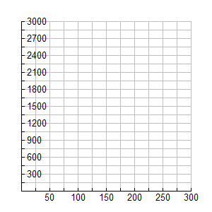  Point of intersection:_________________ | Substitution Method  Point of intersection:_________________

4.7.5: 3 Ways (Continued)

Elimination Method  Point of intersection:____________________ | The student council has $1 800 in their budget for the lunch. They prefer Let’s Do Lunch, what is the greatest number of grade 10 students they can have at the lunch?
What does the ordered pair (25,750) mean on the Lunch Express line?

